|  |  |
| --- | --- |
| EduCycle Database  Application  [Spr 2020] |  |
|  |  |
| User Guide  Authored by:  Alexander Dao  Turhan Kimbrough  Andy Stoerkel |  |

Table of Content

1 Introduction 2

2 Key Features 3

3 Admin Users 4

3.1 Log-in 3

3.2 Main Interface 5

3.3 Service Request Page 7

4 Admin Users & Student Employees 14

4.1 Login 14

4.2 Equipment 14

4.3 Equipment Type 20

5 Logout 24

# 1 Introduction of the EduCycle Database Search System

## 1.1 Who Should Use This Application

Towson University’s Office of Technology Services has created the EduCycle Program to reuse and recondition out-of-life cycle university computers. Since 2014, this program has been running strong and...

This application will provide the facility, staff, and student employees of OTS with a concrete database to hold current data on reconditioned computers and reconditioning sessions that were received by Baltimore Public Schools.

## 1.2 Who Should Use This Application

This guide is intended for the faculty and staff at the Office of Technology Services who has control over the EduCycle Program and the students they have under them.

* Admin User: Administrative users can learn how to log in to their accounts and manage all of the information that EduCycle receives

# 2 Key Features

## 2.1 Features for Administrative Users

The following are key system functions available to users who are administrators in the program:

* View computers that have been reconditioned and which have not
* Show the location of all of the Equipment
* View students who have volunteered
* Show the reconditioning sessions
* Add and remove Equipment from the database
* Show the number of hours that a faculty and student have worked
* Can track the breadcrumbs of where a computer has been
* View Service Request ticket information of
  + Departmental Staff at Towson University
  + Baltimore Public Schools information
* View which Baltimore Public Schools have been a part of EduCycle

# 3 Admin User

# This will teach general managers on how to use this application.

## 3.1 Login

When launching the application, the user will be able to log in to database with their username and password. (Figure 1).

When entered, click on the “Enter” button

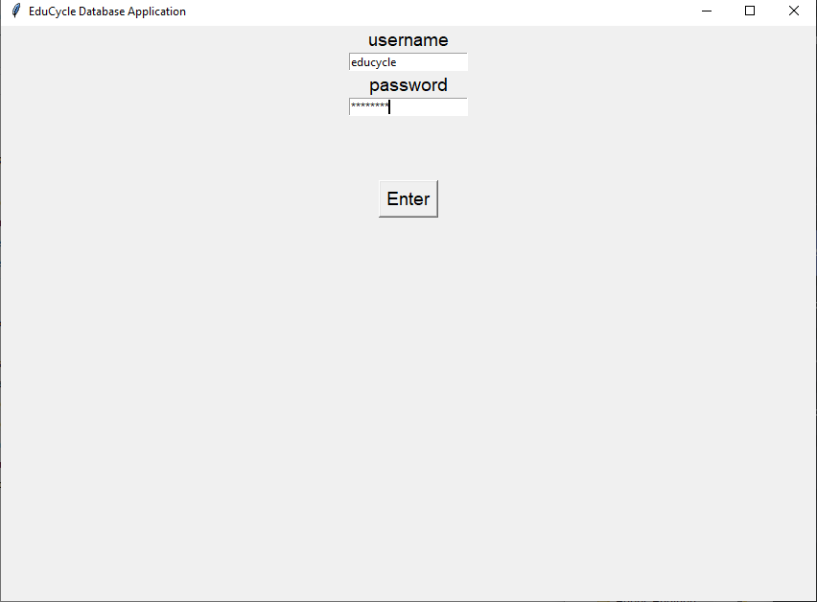

Figure 1

If the username and/or the password is incorrect. There will an error message that will appear that will notify the user and will not let the user to log in.

## 3.2 Main Interface

After the login page, you will be led to the main menu that will have a dropdown menu (figure 2).

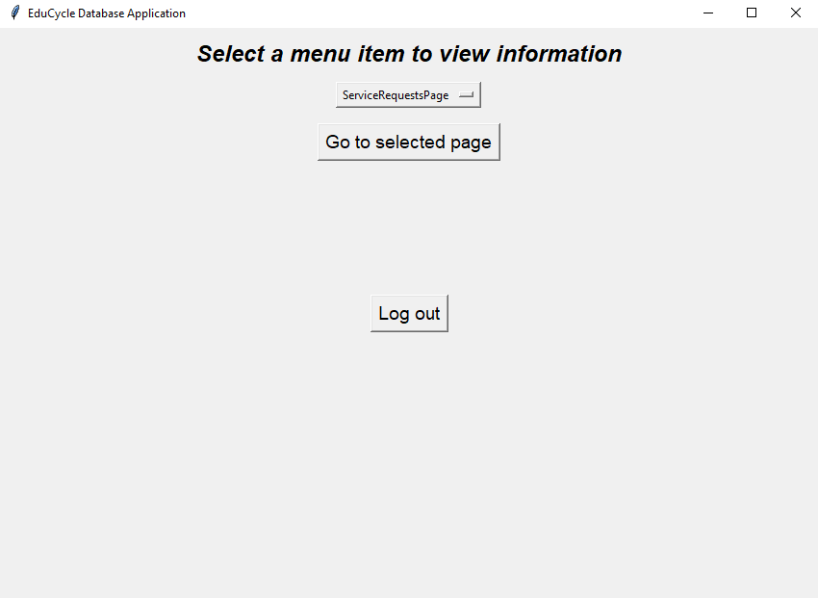

Figure 2

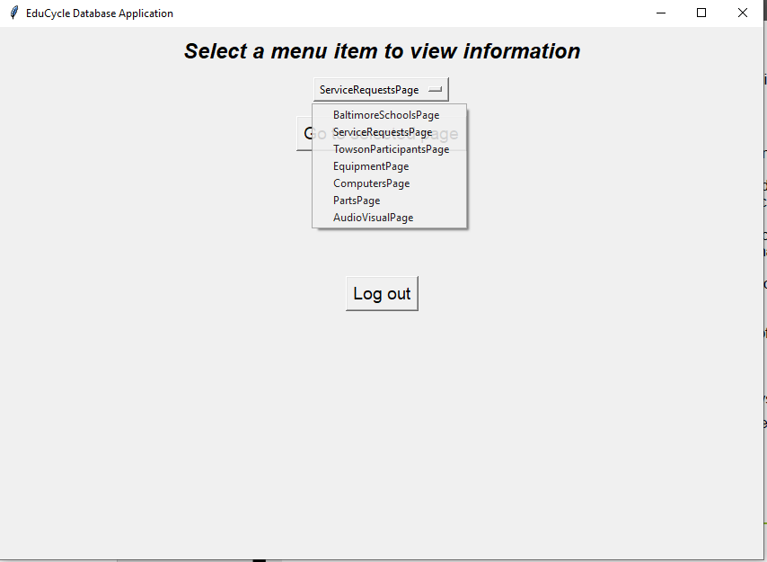When the dropdown menu is clicked, you can go to multiple pages the database holds. Admin users will be the only one who can have access to “ServiceRequestPage” (figure 3).

Figure 3

## 3.3 Service Request Page

After you select “ServiceRequestPage” from the dropdown menu, click on the “Go to select page” function to be transferred to the Service Request Page (Figure 4).



Figure 4

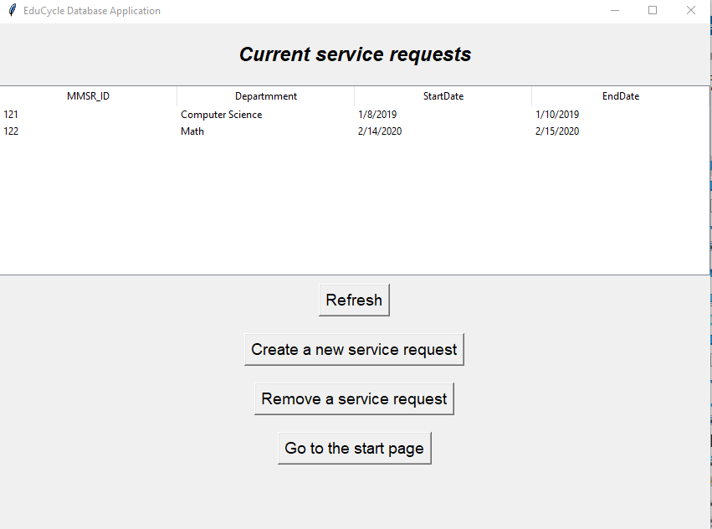This will access the information of the Service Request (SR) that has been inserted into the database. Only Admin users can access this data, such as MMSR_ID and which departments have SRs assigned to them. Clicking on the “Refresh” button will manually update the page (Figure 5). To create a new service request, click on the “Create a new service request” button and it will lead you to a page to insert data into editable fields (Figure 6).

Figure 5

Figure 6

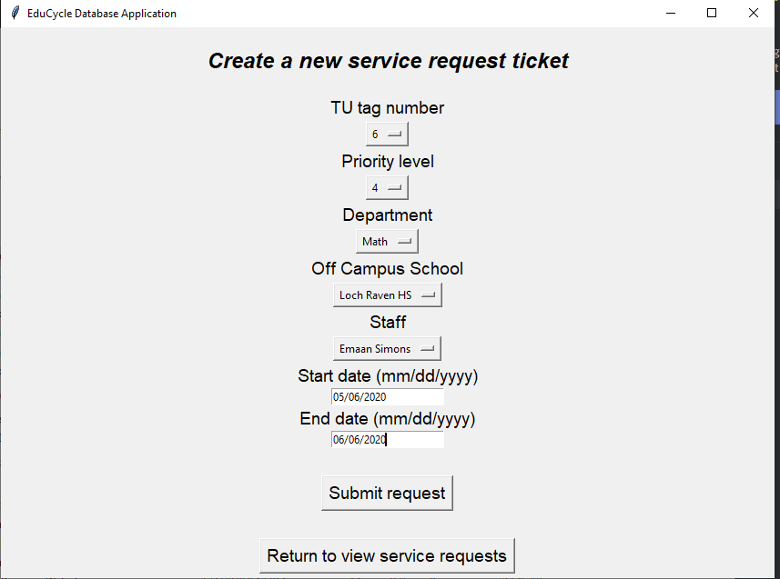Below are the descriptions of the sections above (Figure 6):

* TU Tag Number – Towson University Technology Identification Number
* Priority Level
  + 1: Low priority
  + 5: High priority
* Department – Department name that the service request is meant for
* Off Campus School (if department is empty) – School that placed in the request
* Staff – Name of the staff member that is in charge of the service request
* Start Date – the beginning date of the Service Request
* End Data – the end date of the Service Request

When all of the areas are filled. Click on “Submit request” on the bottom page. (Figure 6). The provided information is now stored into the database. To access and view the inserted data, click on the “Return to view service requests” button to return back to the main screen of the service request page.



Figure 7

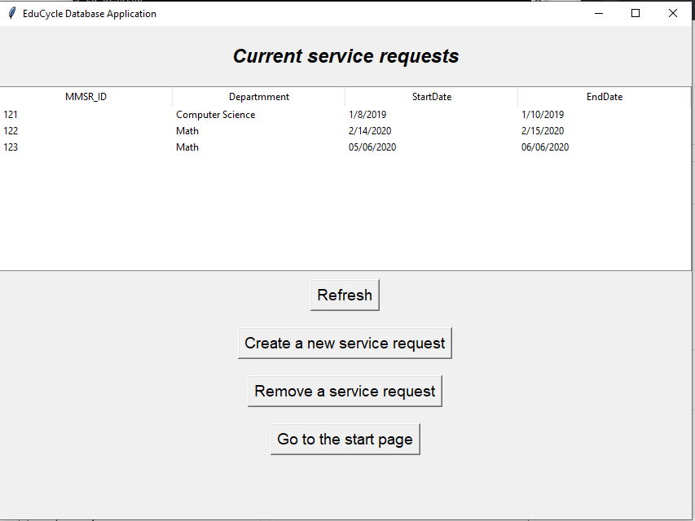

If the user just inserted data into the database. The “refresh” button has to be click to have it manually update the page (Figure 7).

If the User clicks on “Remove a service request” button below “Create a new Service Request”, they will be shown a page that will have a field that will ask for the Service Request ID that the associated Service Request is connected to (Figure 8).

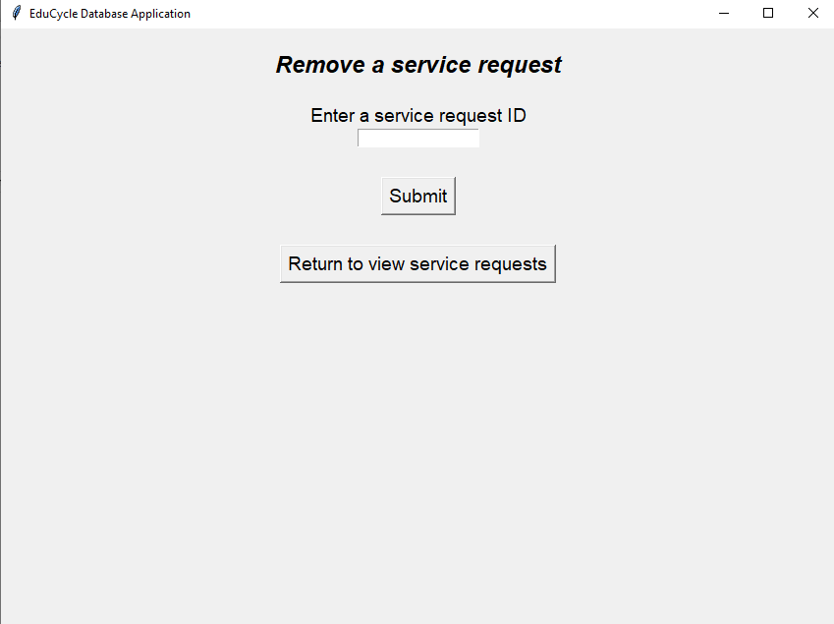

Figure 8

Once the ID is inserted and the “Submit” button is selected, it will be deleted from the database. To access and view the inserted data, click on the “Return to view service requests” button to return back to the main screen of the service request page (Figure 9).

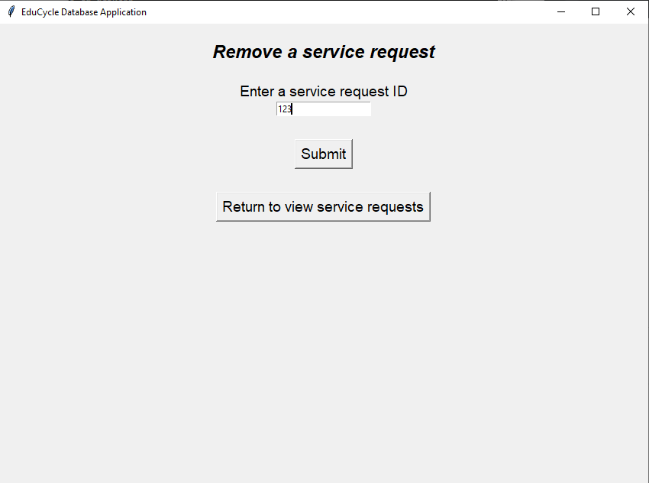

Figure 9





Figure 10

If the user just inserted data into the database. The “refresh” button has to be click to have it manually update the page (Figure 10).

# 4 Admin User & Student Employees

# This will teach admin users and sections student employees can have access too.

## 4.1 Login

Please refer to section 3.1, the log in process is the same for admin users and student employees.

## 4.2 Equipment

On the main page of the application. Certain categories can be viewed (Figure 11).

Figure 11

The following tables can be viewed to both the user admin as well as the student employees:

* Baltimore School Page
* Towson Participant Page
* Equipment Page
  + Computer page
  + Part Page
  + Audio Visual Page

The steps to view/insert/delete data from these tables are similar. Follow the following steps to learn how to use all these functions to each of the tables.

(For User Guide sake, we will use Equipment section to explain how to use the view/insert/delete feature)

To get to the Equipment page. After the login page, you will be led to the main menu that will have a dropdown menu (figure 12).



Figure 12

When the dropdown menu is clicked, you can go to multiple pages the database holds (figure 13).



Figure 13



Figure 14

After you select “EquipmentPage” from the dropdown menu, click on the “Go to select page” function to be transferred to the Equipment Page (Figure 14).

This will access the information of Equipment that has been inserted into the database. Users can access and view the data, such as TU_Tag_Number. Clicking on the “Refresh” button will manually update the page. To create a new entry for an Equipment. Click on the “Enter new Equipment” button and it will lead you to a page to insert data into editable field (Figure 15).

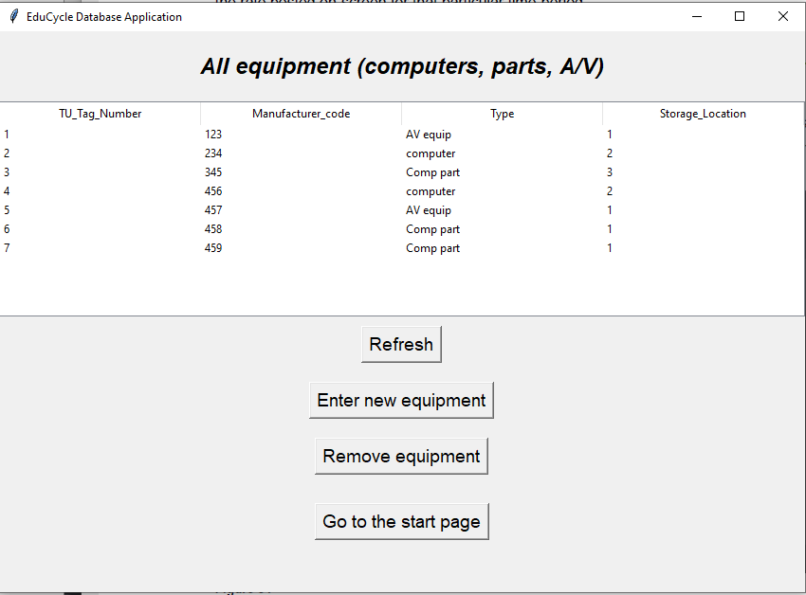

Figure 14

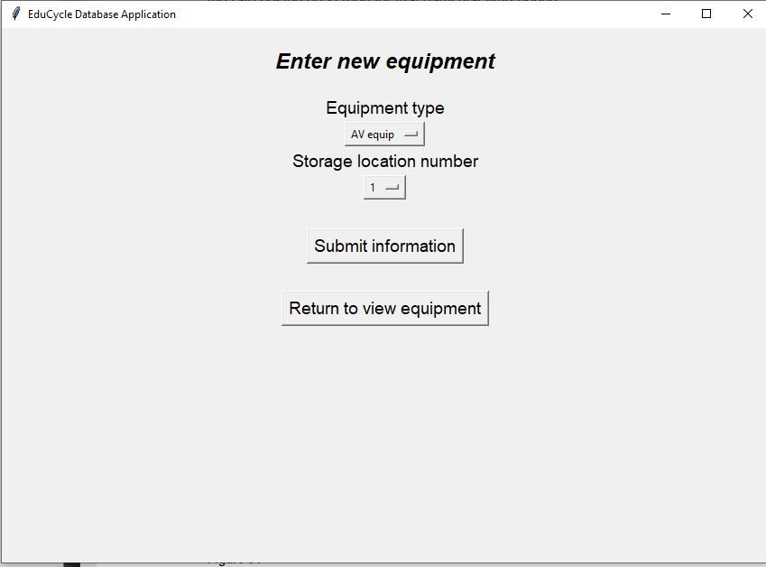

Figure 15

Below are the descriptions of the sections above (Figure 15):

* Equipment Type:
  + AV Equipment
  + Computer
  + Computer Parts

## 4.3 Equipment Type

A/V Equipment

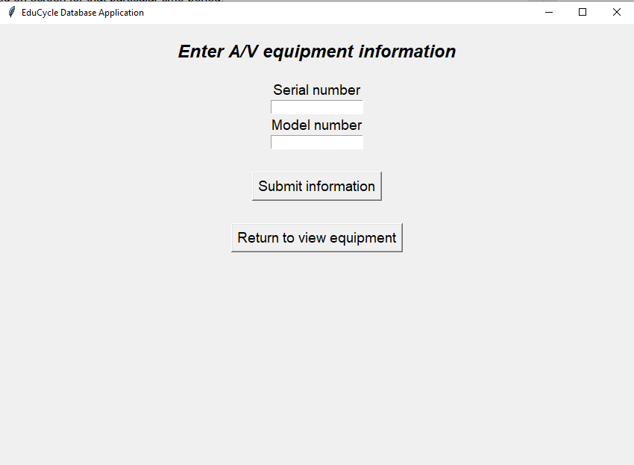

Figure 16

Below are the descriptions of the sections above (Figure 16):

* Serial Number – Serial Number that is associated with the Tech
* Model Number – Model Number that is associated with the Tech

Computer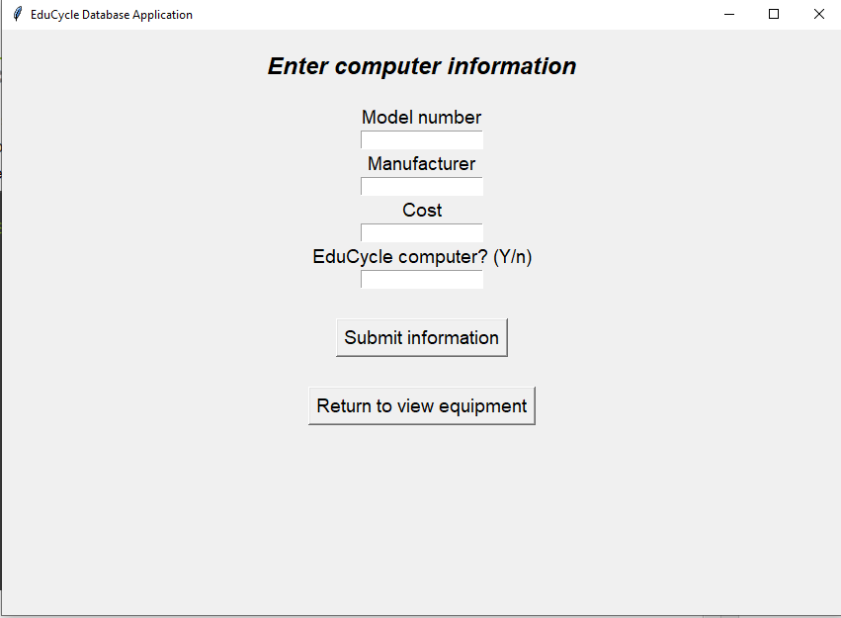

Figure 17

Below are the descriptions of the sections above (Figure 17):

* Model Number – Model Number that is associated with the Tech
* Manufacturer – Dell or Mac
* Cost – price of the computer
* EduCycle Computer – Did this computer go through EduCycle

When all of the areas are filled. Click on “Submit Information” on the bottom page. The provided information is now stored into the database. To access and view the inserted data, click on the “Return to view Equipment” button to return back to the main screen of the Equipment Page (Figure 18).

Figure 18

If the user just inserted data into the database. The “refresh” button has to be click to have it manually update the page (Figure 18).

## 5.1 Logout

To log out of the application, the user must click on the button “Logout” on the button of the start page of the application. When the user clicks the button, they will be led to the log in screen (Figure 19).

Figure 19